 | Using the E2BN Galleries | 

How to view and download image, video clips and audio clips

The E2BN Gallery system contains thousands of high-quality, copyright free images. The gallery also hosts video clips and audio files. All of these can be downloaded by users of the site.

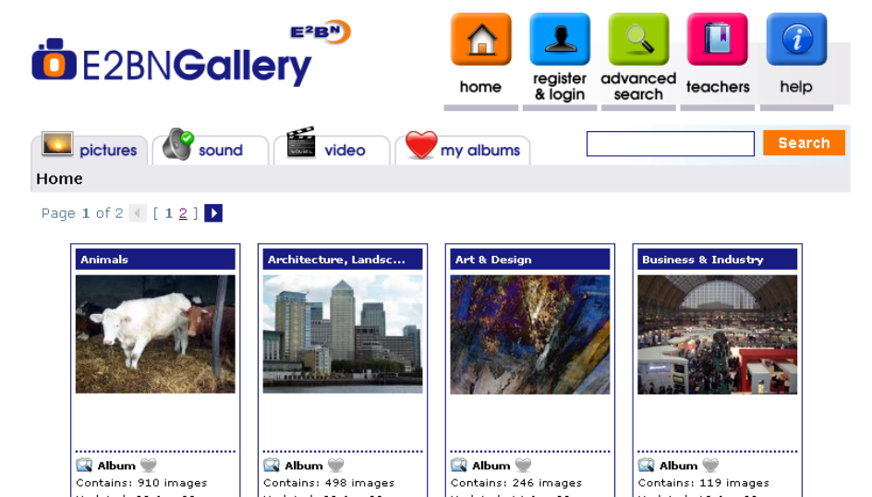

You can find the images and clips you want in a number of ways:

- By browsing the albums
- By using the search facility to locate resources

Browsing the albums
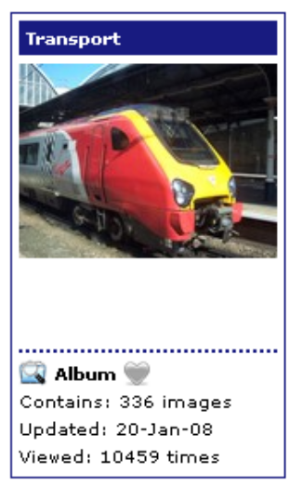
Find the category of images which most likely holds what you are looking for.
For example to locate pictures of steam trains you might start by looking in the album called ‘Transport’. The cover tells you how many images are inside the album, the date that the album was last updated and how many times they have been viewed.

Click on the album cover to open the album. It is most likely that this will then reveal further albums, as below:

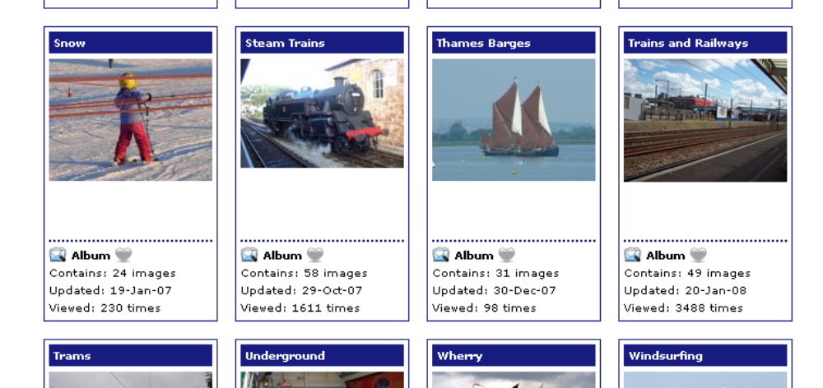

Click on the chosen cover to open the album – clicking on the album called ‘Trains and Railways’ reveals a mixture of albums and individual images. Clicking on an album will open that album, whilst clicking on an individual image will open that image in a larger view, as below:

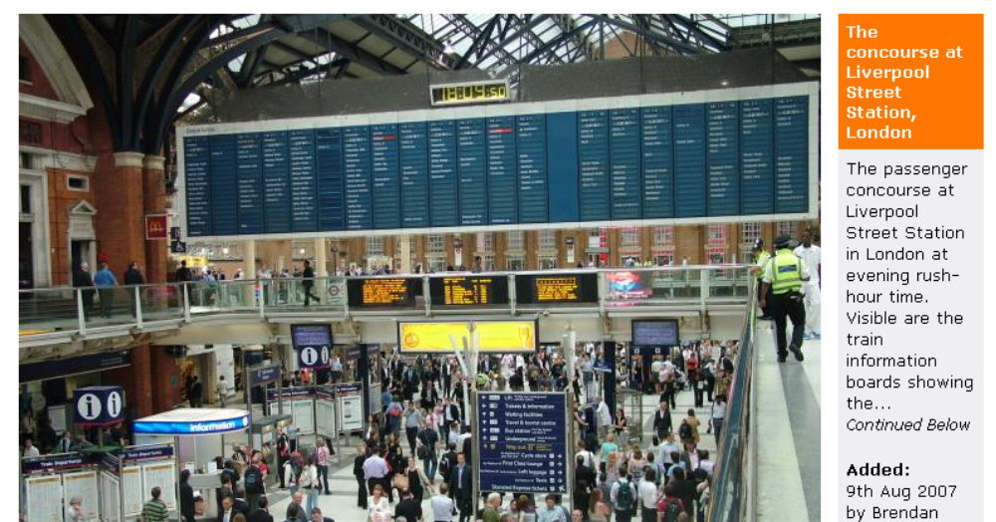

Clicking on the large picture will often result in the system opening a still larger version of that image.

Images can be downloaded by clicking on the download links which can be found to the right of the image

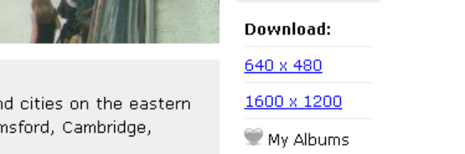

When these are clicked a box will open asking whether you wish to open or save the image - choose ‘Save’ and save it to your computer.

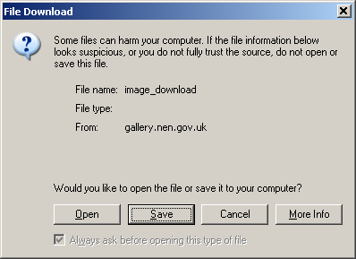

To locate video or audio clips, follow exactly the same process as for images.
Click on either the sound or video tab at the top of the gallery screen:
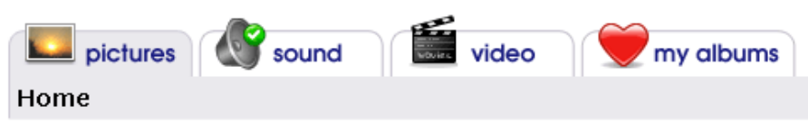

Clicking on the video tab will open the video collection, as shown below:

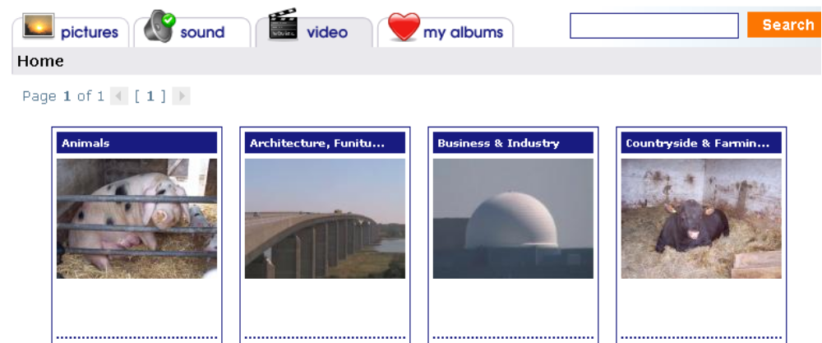

Open an album by clicking on it,

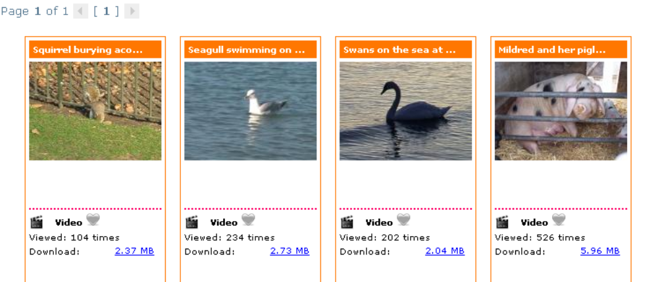

then view the selected video by clicking on it. This will cause it to open in a new page. The media player on the page will automatically play the selected clip, once it has downloaded a sufficient amount of it to begin playing.

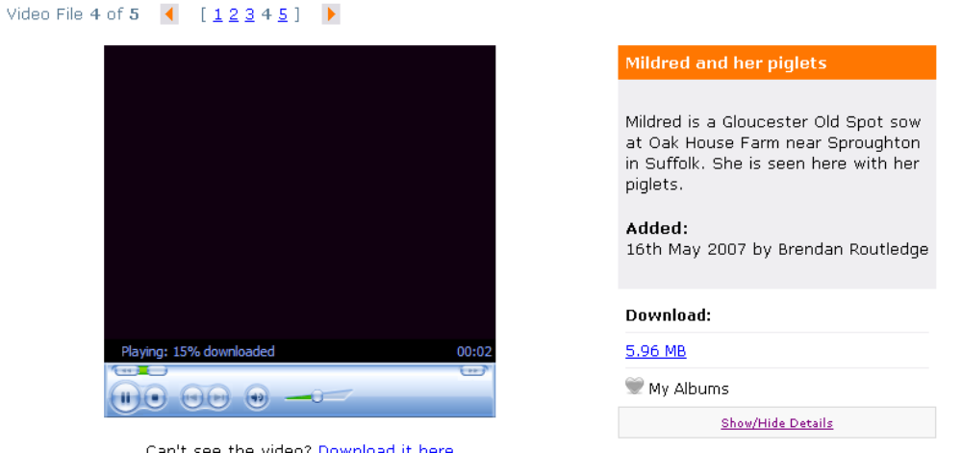

Audio files will open in the same way and will play in the embedded audio player.

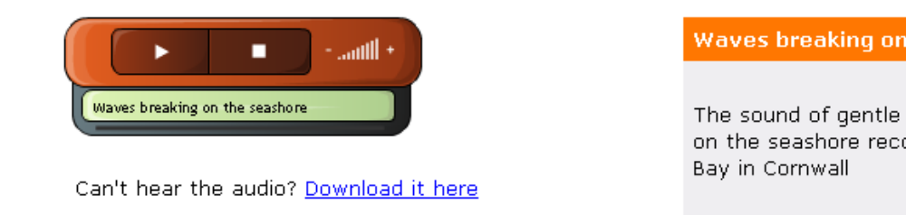

Using the Search tools to locate resources

The gallery allows users the chance to search for resources by using either the basic or advance search tools.
The basic search tool can be found at the top of every page in the gallery just below the five coloured buttons:

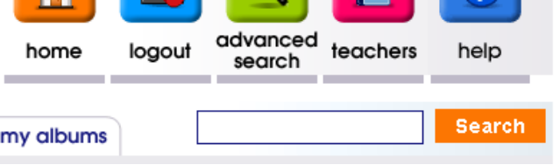

Simply enter a search term in the basic search box and click the ‘search’ button:

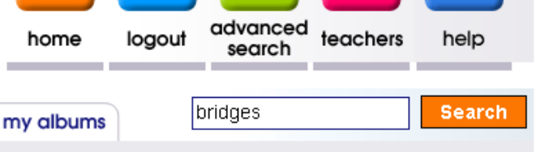

The results of your search will be displayed as a series of albums and images as in the example below:

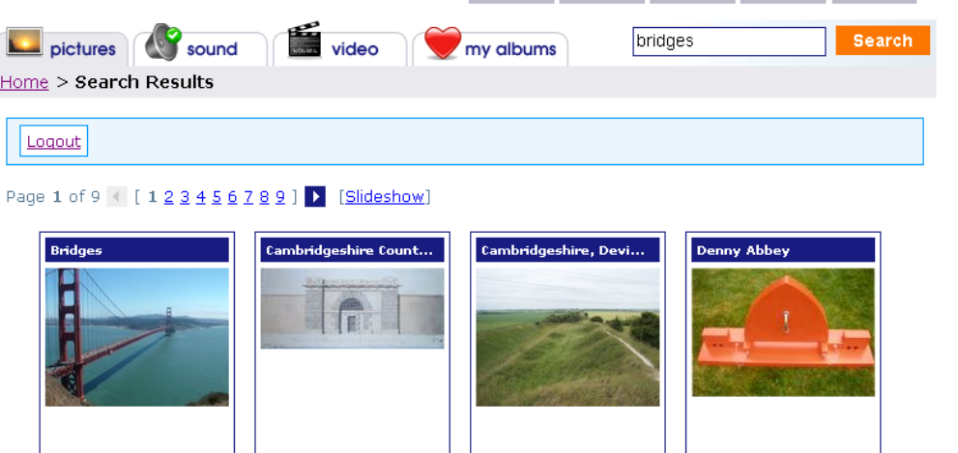

Clicking on an album or image will open it up as described previously.

However users can use the ‘advanced search’ tool to make their search more specific by searching based on subject or key stage or year group or end user group. Click on the ‘advanced search’ button to access this tool.



This will bring up the ‘advanced search’ options as shown below:

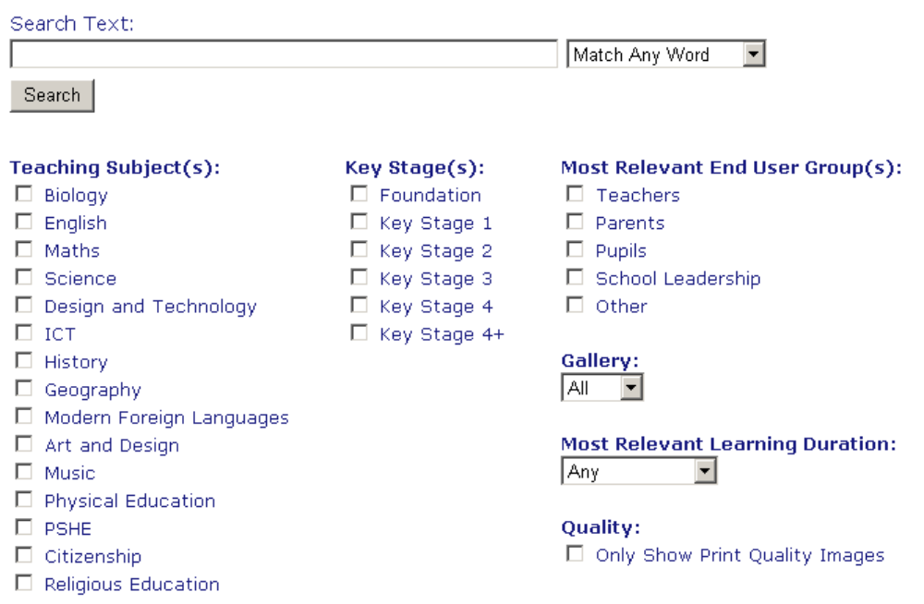

Users can select one subject or a range of subjects to help narrow down their search. The same is true for key Stages and so on. For instance a user might search for ‘Castles’ and narrow this down by ticking ‘History’, ‘Key Stage 2’ and ‘Pupils’ and also specifying that the search should only look for Images:

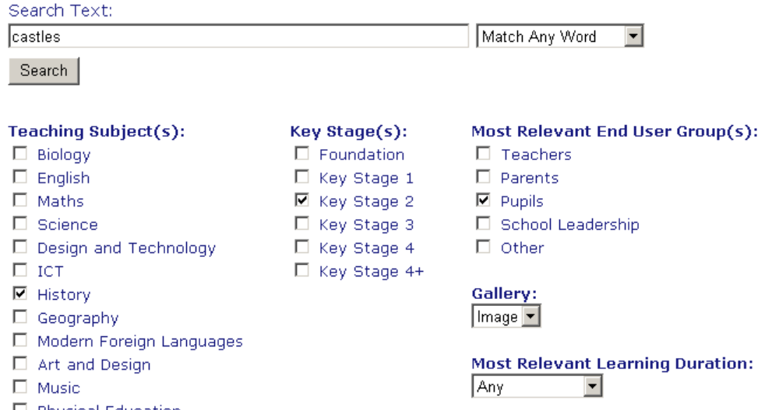

As items are uploaded they are tagged in terms of subject relevance, age relevance etc and so as long as resources are correctly tagged the advanced search should locate suitable images and clips.

