 | MLA East of England  ICT and Schools Workshops | 

Protecting Your Assets

In some cases you may be happy to let people have very high-resolution images of documents and artefacts whilst at other times you may feel that you wish to protect a particular asset, allowing people to view it but not to download it for their own use.
Completely protecting image assets which are posted on web sites is very difficult but there are a few things which you can do which may deter unscrupulous users from making use of your valuable property.

1. Don’t give the best stuff away
Post lower-resolution versions of your images which are less useful to others. Offer users images which are of a size and quality which means it is of little use to them in terms of downloading it, re-purposing it and making some other use of it e.g. printing. In general images on the web are of a lower quality to keep their file-size down which means that pages then load more quickly. When downloaded they are seldom of good enough quality to be useful in print media, for example.

2. Embed a watermark or copyright notice in the pictures
Fully protecting your intellectual property can be expensive. The extent to which you are willing to go will depend on how valuable it is or you believe it to be. For most of us most of the time, we cannot afford or justify going to extreme measure to protect all of our work.
Although a copyright can sometimes be difficult to use and enforce, it is probably the best protection you have in the long run for your assets. Place the statement ‘Copyright (c) year Your name or owner. All rights reserved’ or some other simple to the point message.
This message can be embedded in your images and it is quite quick and easy to do. It is how the British Pathe film Archive protect their 25,000 film clips and 12 million still pictures. Nothing can stop an unscrupulous user cropping the image and chopping off the notice but they have then broken the law and, in most cases, people will not do this.

To embed a copyright notice in a picture using Paint Shop Pro:

- Open an image in Paint shop Pro by going to File – Open or by using the File – Browse function
- Select the Text tool from the toolbar and click on the picture
- In the text box which appears type in your copyright notice, click on the ‘Standard text’ button at the bottom left of this box, then select a suitable text colour so that it will show up on the picture but will not be over-intrusive

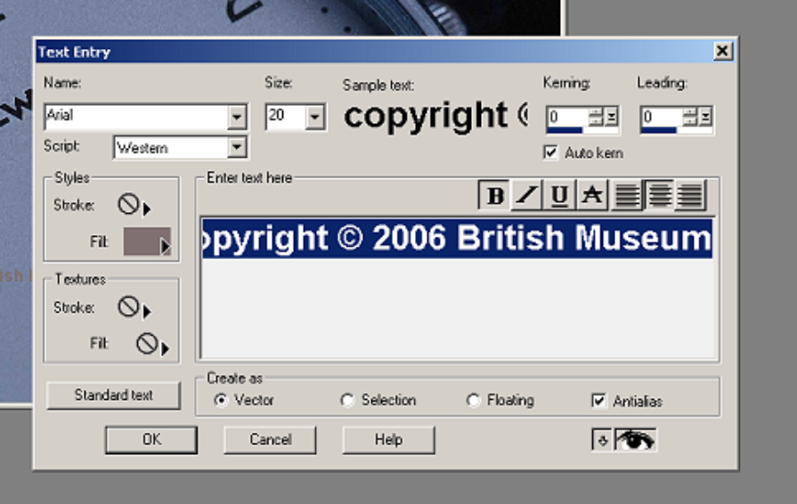

- Click OK – the Text Entry box will disappear and you will be back on your own image. The text entry will be selected and by placing your cursor over the centre of the selected text you can click and drag t into the position you wish it to be, as below.

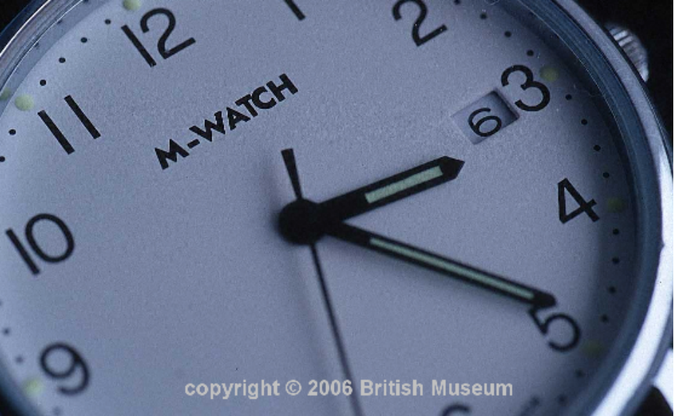

- Now save your image – you should save it as a jpeg (or jpg) image if it is to be used on a website. This format means that the image is saved as a single flat layer so if someone wishes to remove the notice they will have to remove the area of the image around and beneath the notice as well, probably ruining the image in the process.

